Date : 08/11/2026 | Reference : OL-AR-1-1
Edition : 1 | OptiLog – M1

DEVELOPMENT METHODS

TRANSTEC PROJECT

Activity Report

Writer | Project Manager | Quality Manager
Nicolas SENGLER | Nicolas SENGLER | François ROCHE
Signature : | Signature : | Signature :

Number of Pages: 11
Summary
I. Presentation 2
II. The Different Individual Activity Report 3
A. Julien Lacombe 3
B. Sophie Delcour 4
C. Julien Catala 5
D. François Roche 6
E. Nicolas Gautier 7
F. Damien Paul 8
G. Nicolas Sengler 9
III. Group Meeting 10
H. 16/11/05 10
I. 23/11/05 10
J. 28/11/05 10
IV. Technical Progress 11
V. Planning 11

Presentation
The CRA reveals group working, and progress. We will first present you the activity report of each person, and then we continue on the group meetings. We will finish on the technical advancement.

The Different Individual Activity Report

Julien Lacombe

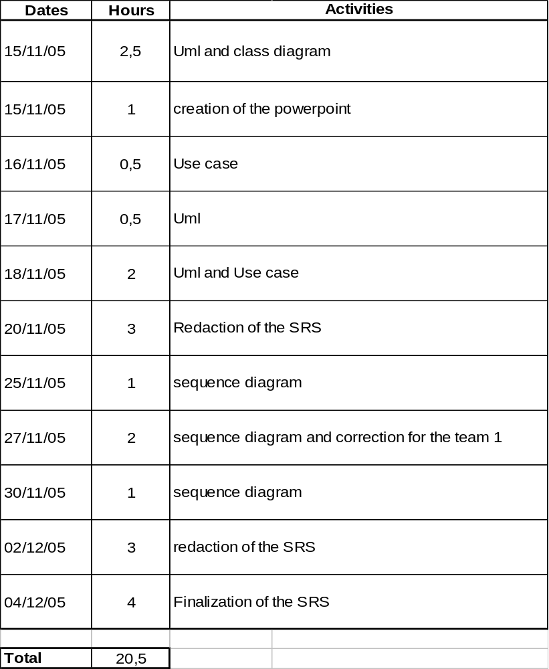

Sophie Delcour

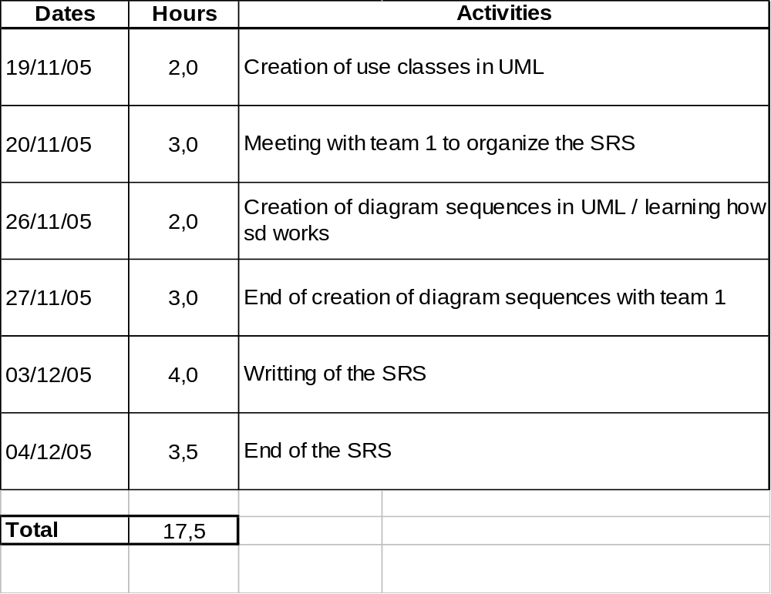

Julien Catala

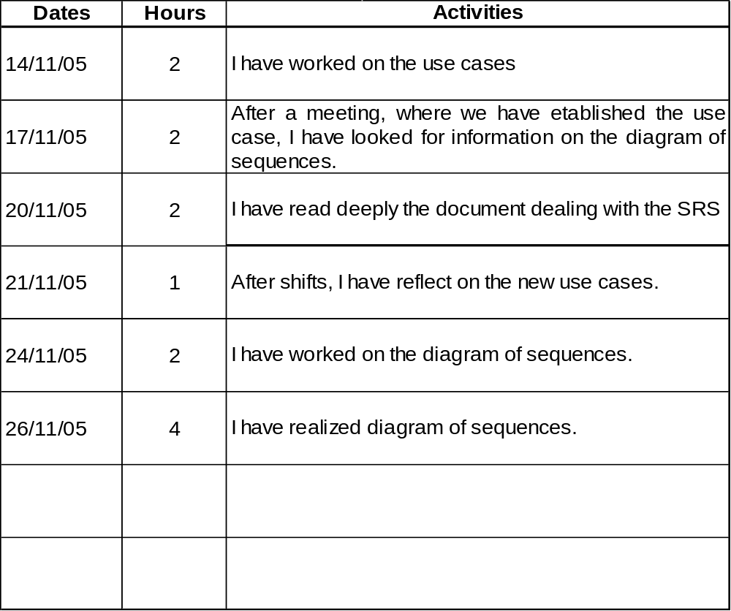

François Roche

Nicolas Gautier

Damien Paul

Nicolas Sengler

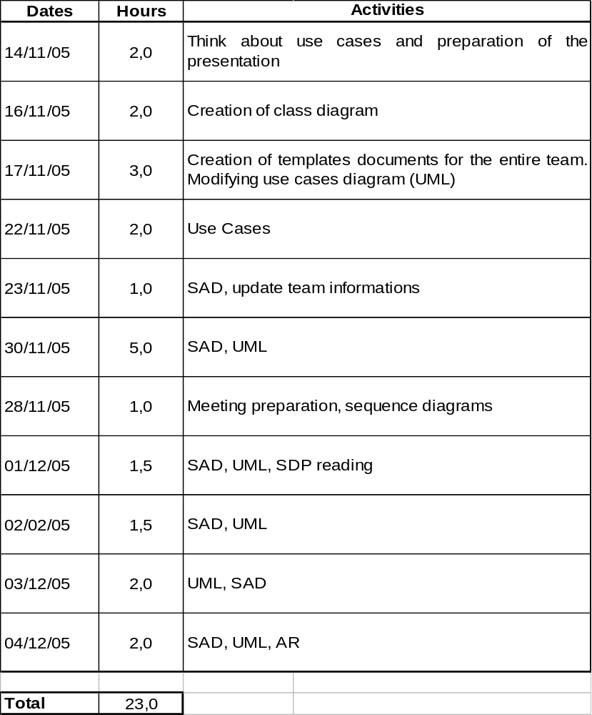

Group Meeting
We ordered the different meeting by date, if we don’t precise anything about the attendance of group members; it means that they were all at the meeting.

16/11/05
The main topic of this meeting was the conception of the use cases diagram. Each member should think about a diagram.
So during the meeting we created together a first draft of diagram. We continued on a small debriefing of the teacher meeting.
Julien L. created the diagram on Rational Rose.

23/11/05
We had one absent Sophie D.
Each member should think about class’s diagram.
Topics were following of use cases diagram, and creation of class’s diagram.
We created the second version of the use cases diagram, directly with Rational Rose. Then we listed the classes and the attributes of each. We closed the meeting with a model of sequence diagram.
The project manager assigned creation of sequence diagrams to each sub team.
Nicolas S. created the first version of class diagram with Rational Rose.

28/11/05
Each member should fix problem on the diagrams.
We checked together every sequence diagram, and then had a look to the other diagrams.

Technical Progress
We had a look how to insert C++ language into JAVA programs, to have a better algorithmical performance.
With the software architecture document we built the first step to start the programming part.
We installed Eclipse on our computers for programming and had a look to the different library (package) we will use.
We looked on the internet to create a CVS server. During the holidays will set up it to start programming efficiently in January.
We activated a data base server, so now we can create the different tables.
The main critical points will be the two algorithms, so we will do some research during holidays.

Planning
Until now, each team has respected the deadlines of our planning, fixed four days before the documents return. But now we have to divide programming part, and in parallel we have to produce documents.
So during the holidays, we will correct the business plan, create the different tables of the data base, create an access to the data base, create the graphical interface, think about the algorithms.
If all these are done, we will start during the first week of January general programming. Each team will have a part of the program, and each member of sub teams, will have different task to do inside the “package”.

